**Vinyl Tracker: Application Instruction**

Dive into the Vinyl Tracker, where music's rich tapestry is woven into an intricate database designed for discerning audiophiles, meticulous collectors, and professional record stores. This application is your ally in capturing the essence and connections of your vinyl records through its intelligent relational structure.

**Richly-Designed Forms & Contextual Linking:**

* **New Artist Form**: The "New Artist" form serves as the entry point for capturing the essence of new musical talent within your vinyl collection database.

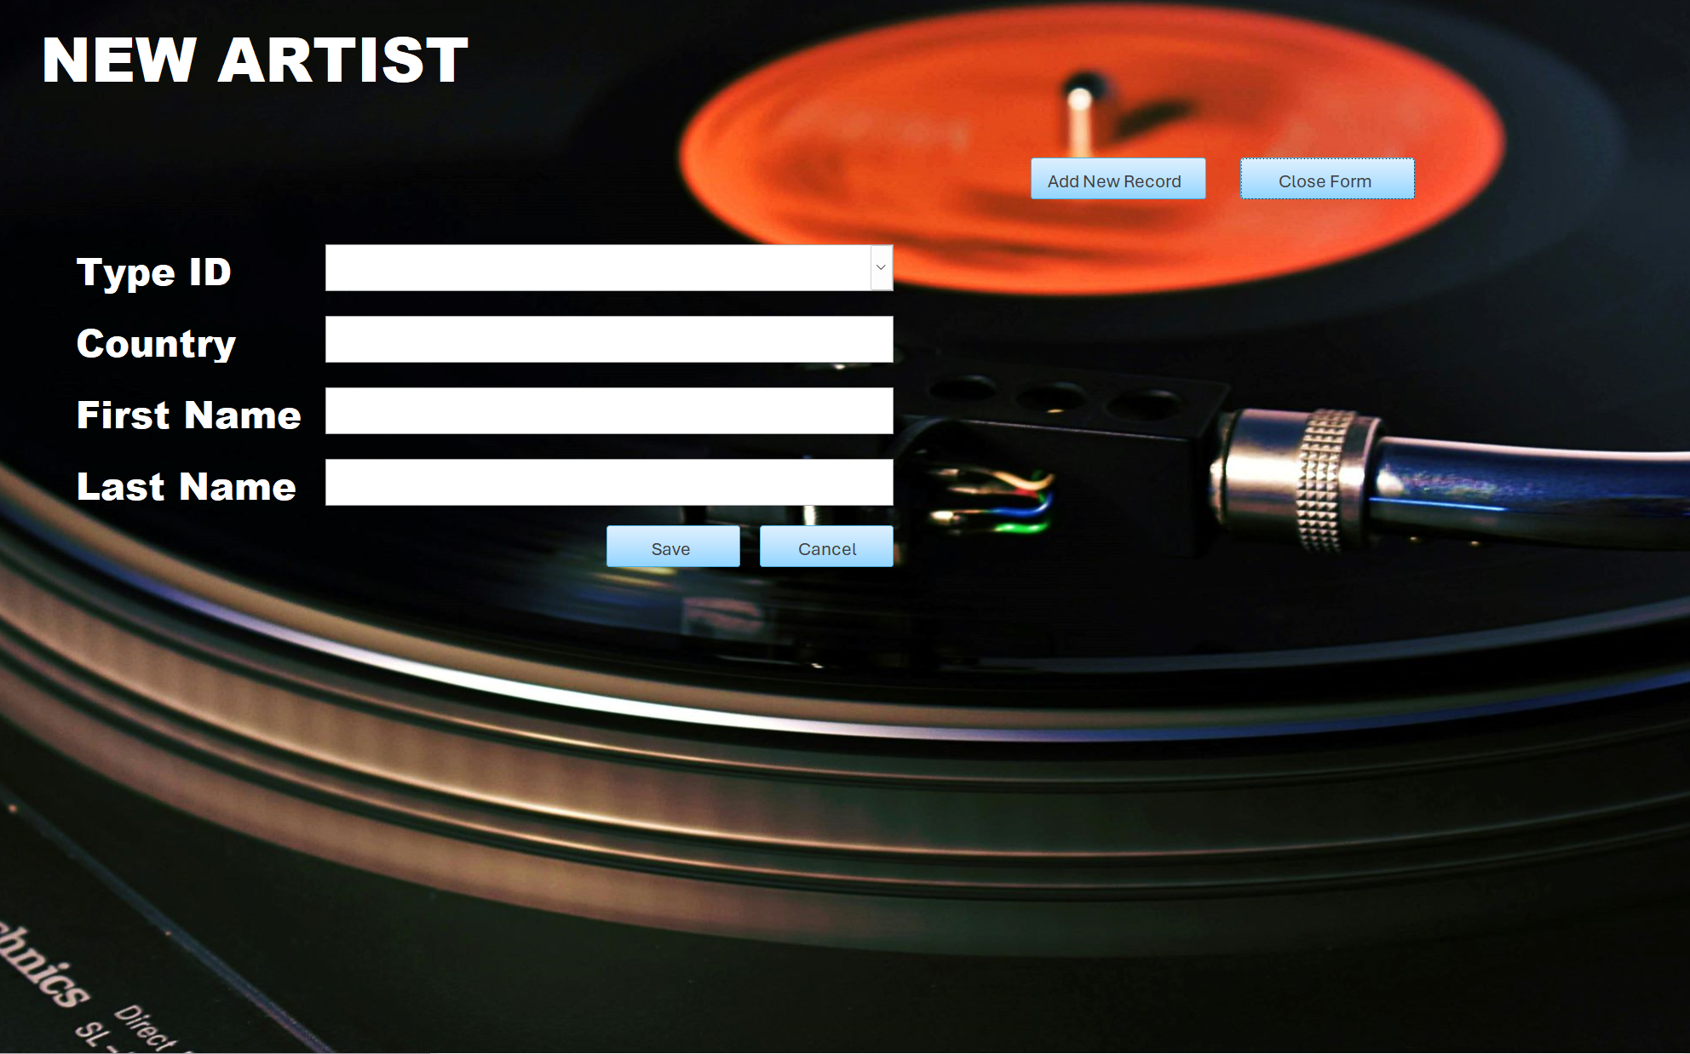

* **Update and Delete Artist Form**: **The "Update and Delete Artist" form is the control center for maintaining the accuracy and currency of artist information in your collection, Offering a snapshot of any previous modifications, giving you insight into the artist's data chronology and ensuring transparency in record-keeping.**

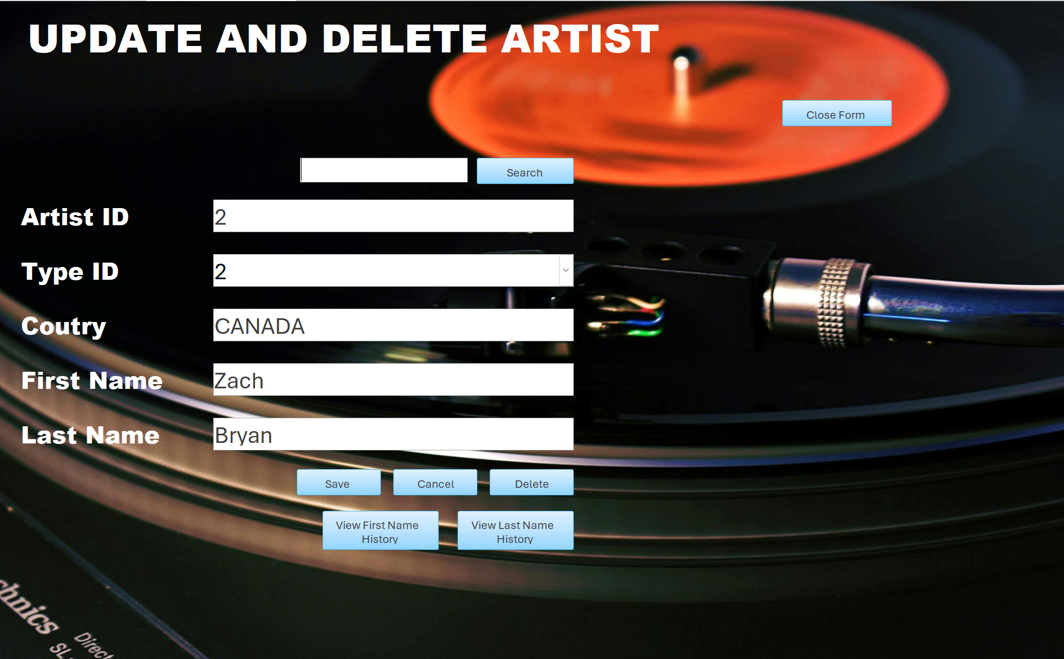

* **Album Form**: Your albums are the stars of your collection. The Album Form is meticulously crafted to catalog every aspect, from the artistic lineage to the nuanced notes of its genre. By archiving the release year, condition, and even cover art, this form becomes a chronicle, elegantly linking to the artists and the tracks, presenting the complete identity of each vinyl.

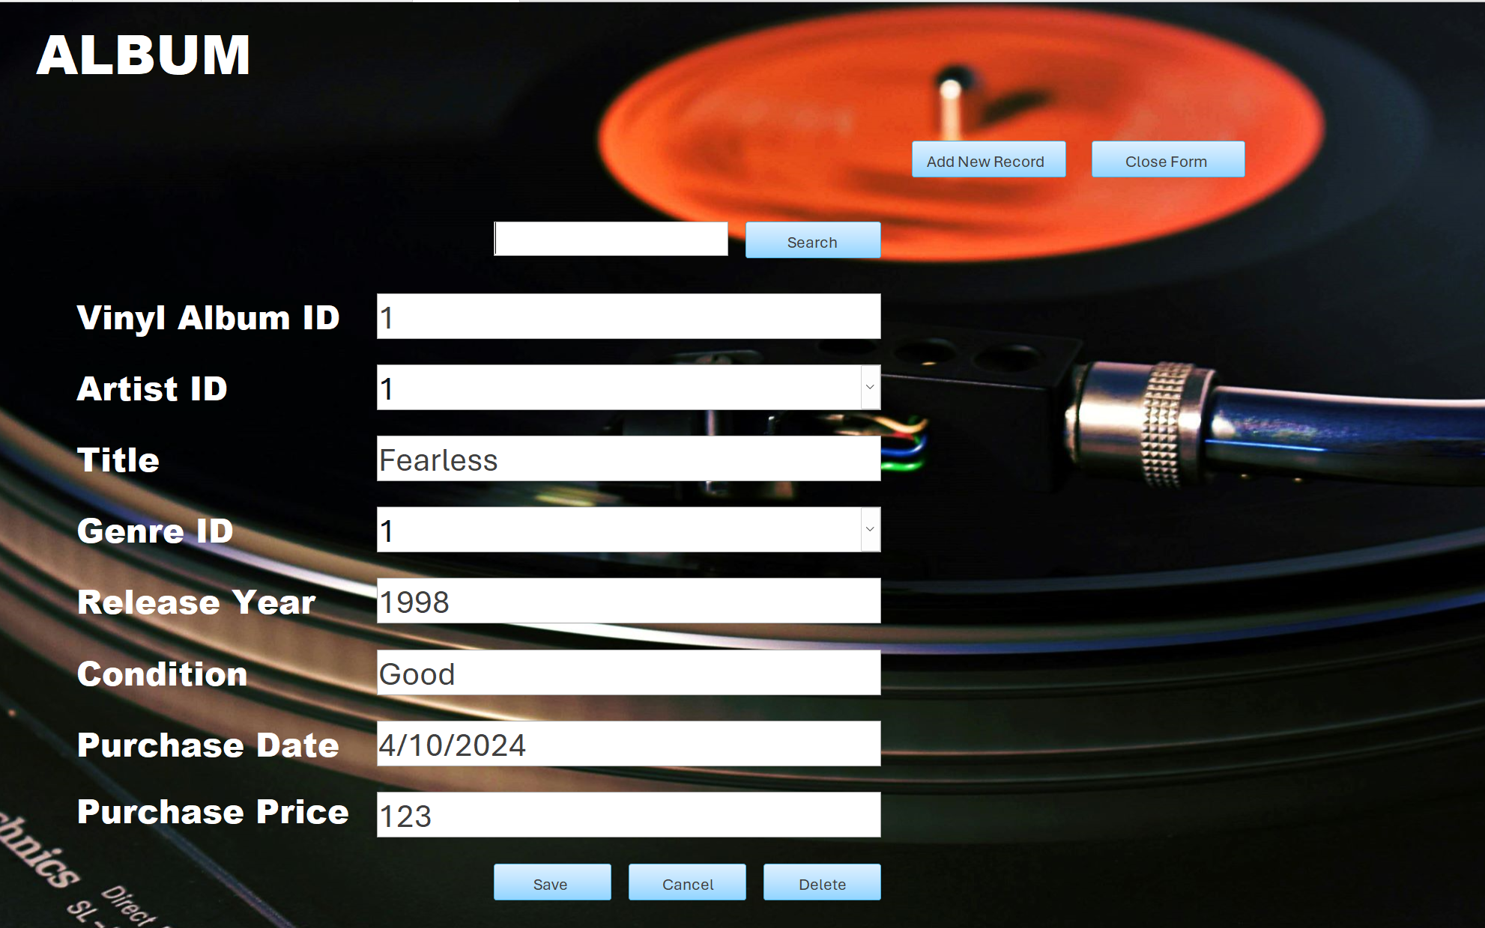

* **Artist Type Form**: Understanding that artists can be multifaceted, the Artist Type Form lets you classify artists into categories like independent, mainstream, session musician, or any unique identifier that fits your collection's narrative.

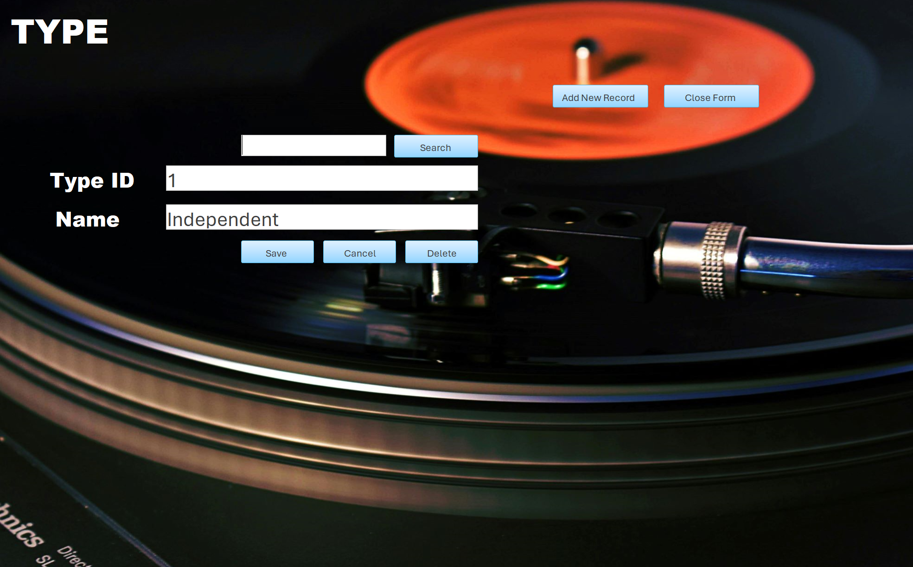

* **Genre Form**: Genres are the colors of music. The Genre Form is your palette, categorizing each album and track to help paint a picture of your collection’s musical spectrum. This form is your guide through the landscapes of Rock, Jazz, Pop, and beyond, illustrating the diversity of your auditory gallery.

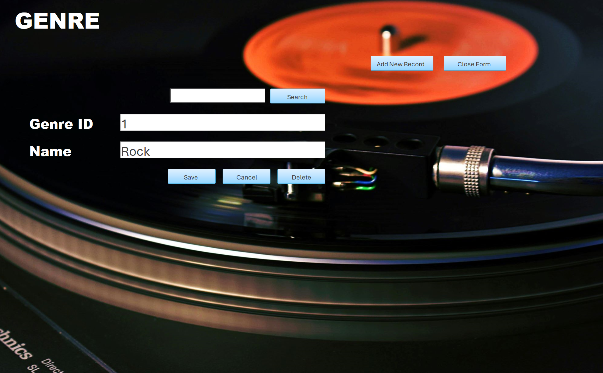

* **Tracklist Form**: Celebrate every beat with the Tracklist Form. It's a meticulous record of every track associated with an album, ensuring the integrity of the music narrative within your database. Every song linked provides a complete anthology of your collection's melodies and harmonies.

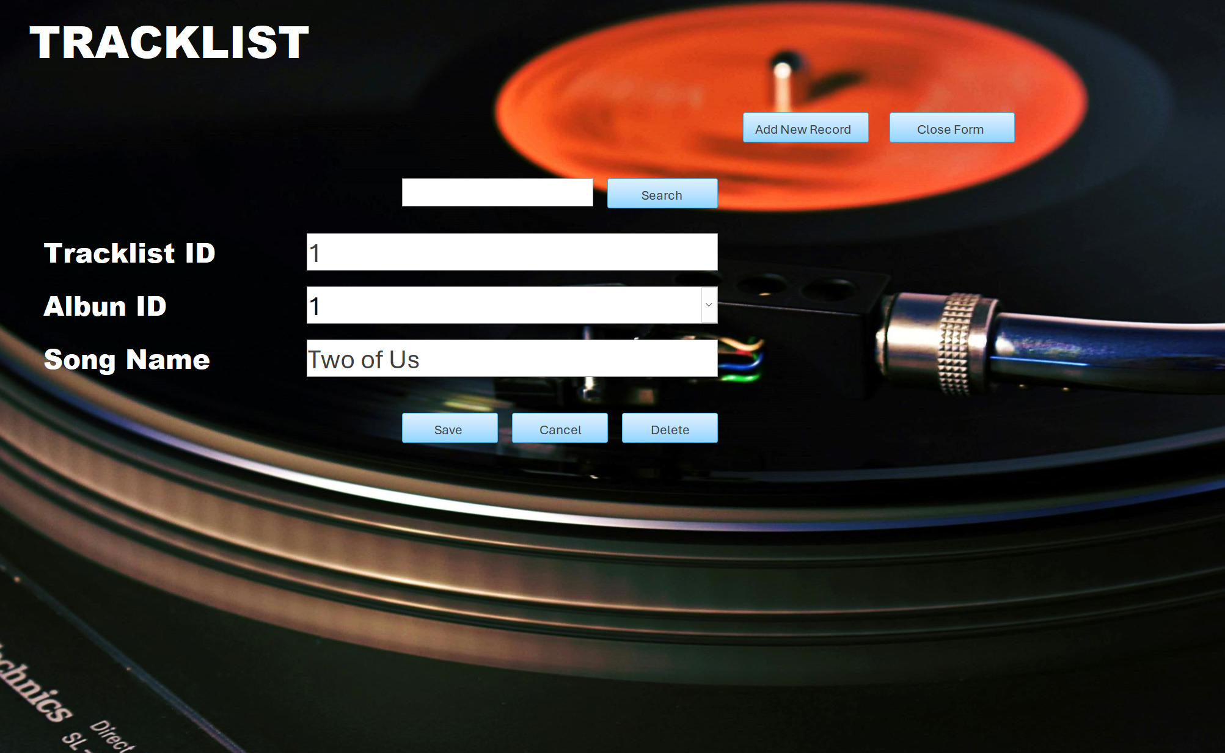

**Analytical Reports & Insightful Overviews:**

* **Album Report**: This report is an orchestral display of your albums, detailing every attribute against the backdrop of cover art, ready to be sorted and admired in a tableau of musical heritage.

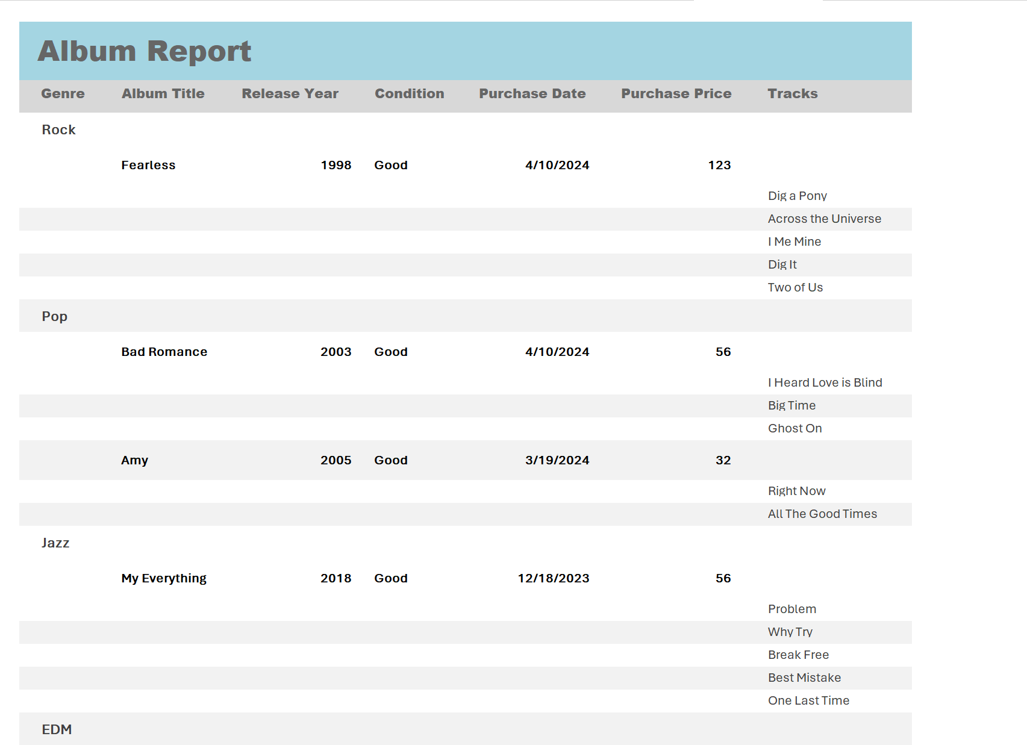

* **Artist Report**: Artists are the pulse of your collection, and the Artist Report illuminates each one's contributions. It showcases an artist's complete works—every album and every track—mapping the breadth of their influence.

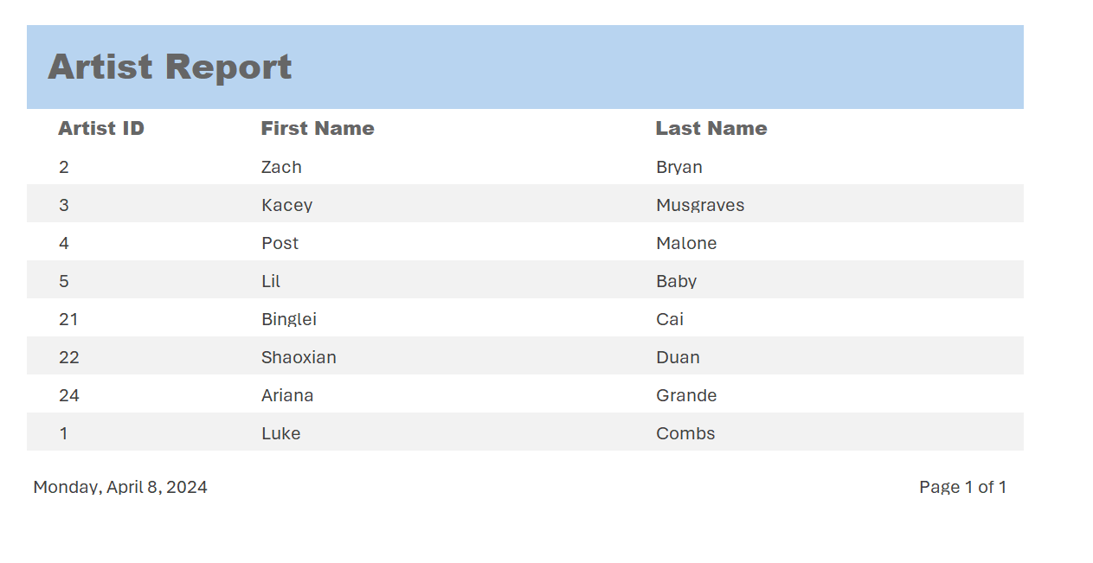

* **Genre Report**: The Genre Report offers an analysis of your musical preferences, plotting the genres across your collection. It's a strategic tool for exploring the genres that resonate with you deeply and those that provide a taste of variety.

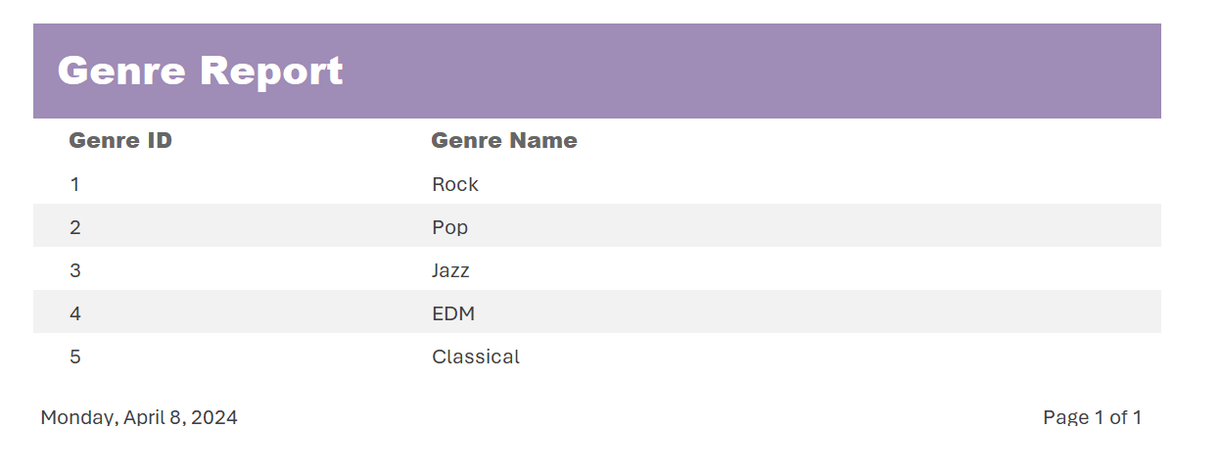

* **Artist Type Report**: The Artist Type Report delves into the types of artists within your collection. It highlights the distribution of independent artists versus signed mainstream acts, giving you insight into the makeup of your collection's artist types.

